12.0 No horizontal scrollbar as expected
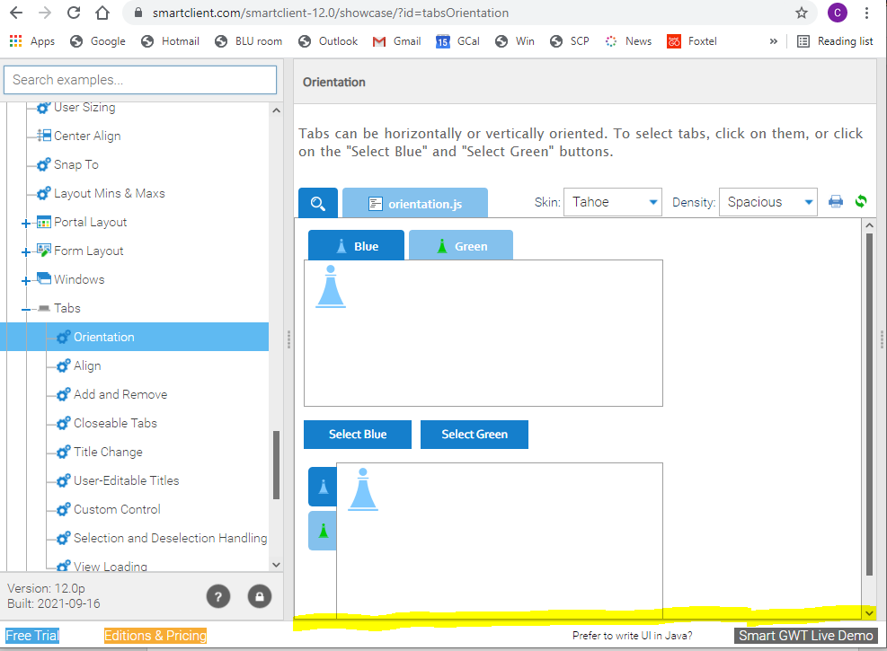

12.1 The UNWANTED horizontal scrollbar pops up
