I’ve added the data set below to show the issues outlined. Also I set “disableWeekends:false”.
Showcase link used: https://www.smartclient.com/smartclient-12.0/showcase/?id=simpleCalendar
{
eventId: 10,
name: "Day of DLS start at 2am",
startDate: new Date(2021, 9, 3, 0),
endDate: new Date(2021, 9, 3, 1)
},
{
eventId: 11,
name: "Day of DLS start at 2am",
startDate: new Date(2021, 9, 3, 3),
endDate: new Date(2021, 9, 3,4)
},
{
eventId: 12,
name: "After DLS start 4th",
startDate: new Date(2021, 9, 4, 0),
endDate: new Date(2021, 9, 4, 1)
},
{
eventId: 13,
name: "After DLS start 4th",
startDate: new Date(2021, 9, 4, 3),
endDate: new Date(2021, 9, 4,4)
},
{
eventId: 14,
name: "Before DLS start 2nd",
startDate: new Date(2021, 9, 2, 0),
endDate: new Date(2021, 9, 2, 1)
},
{
eventId: 15,
name: "Before DLS start 2nd",
startDate: new Date(2021, 9, 2, 3),
endDate: new Date(2021, 9, 2,4)
},

NOTE: Daylight Saving (DLS) time starts in (Sydney/Australia) at 2am on the October 3rd.

Month View
- All six appointments are correctly displayed.
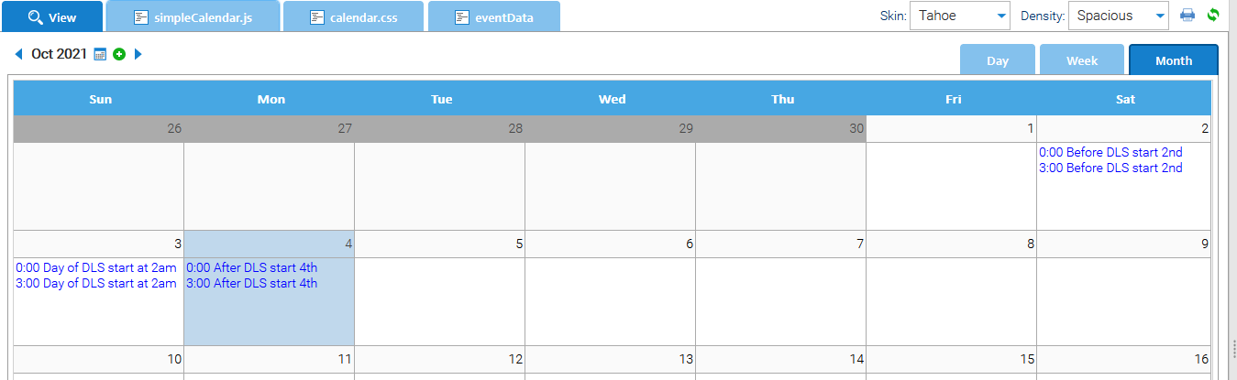

Week View (week before DLS)
- Week before DLS starts looks fine
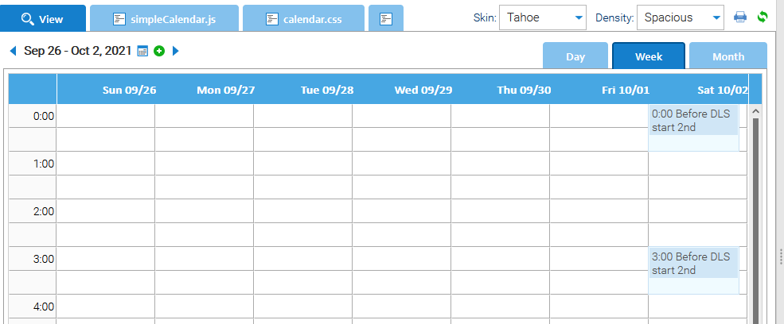

Week View (week when DLS starts)
- Week of DLS now starts on Saturday
- 1st appointment for the 3rd shows in the 2nd column and extends for the day
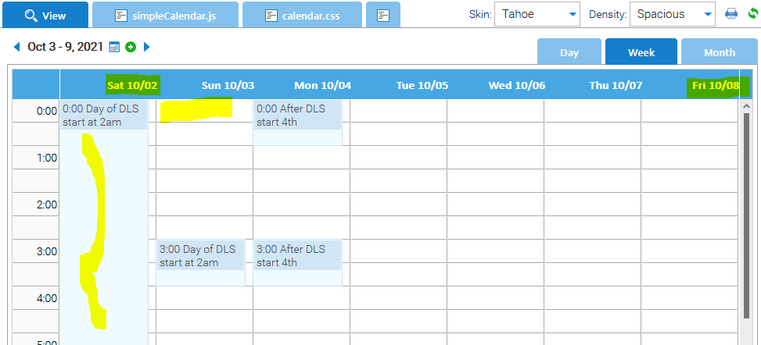

Day View (2nd Oct)
- Day before DLS starts looks fine
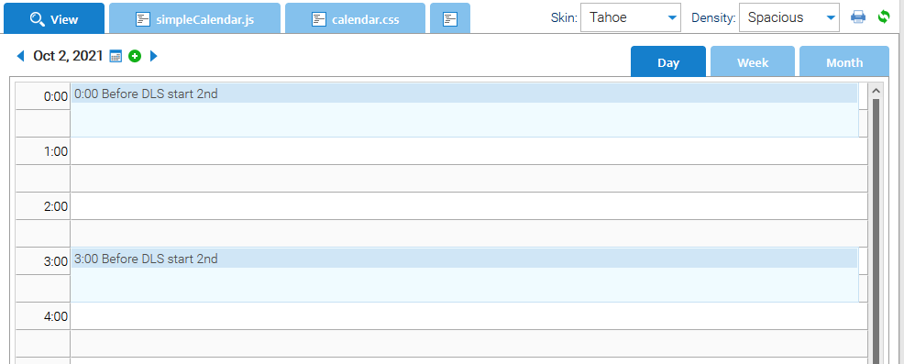
Day View (3nd Oct, DLS starts 2am)
- The appointments for the 2nd show on the 3rd. Any appointment made on the 3rd (DLC start day) will never show with day view. NOTE: If no appointments were set on the 2nd the 3rd would show as no appointments.
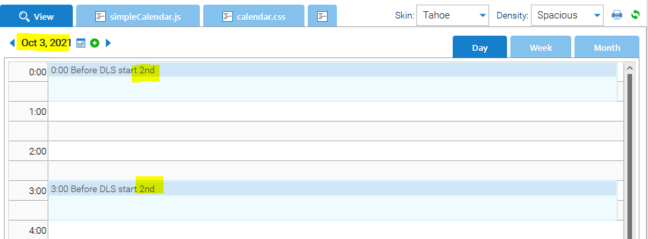
Day View (4th Oct, day after DLS started)
- 4th looks fine
