**Dialog with Smartclient v12.1**

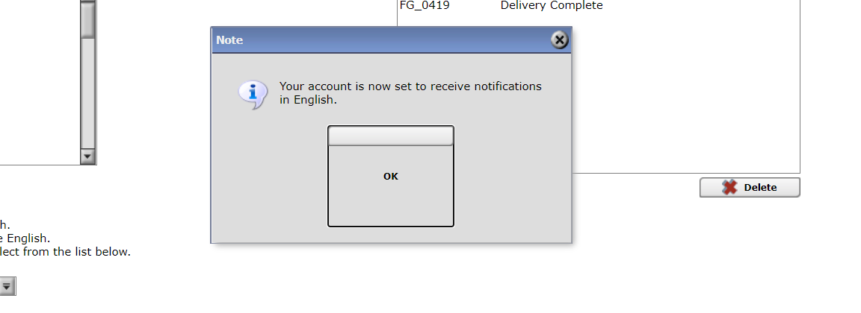

**The ok button has enlarged and looks bad**

**Dialog with smartclient v10 currently**

