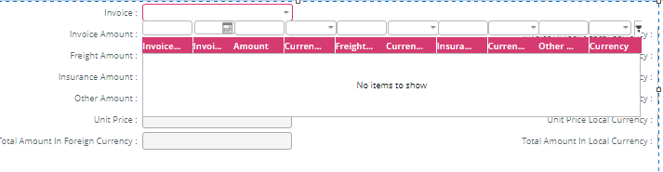

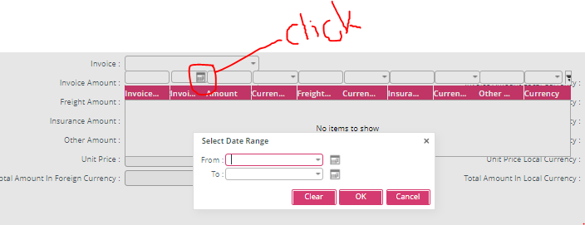

After clicking on the date button of Select Date Range pop-up , previous drop down menu got collapse.

