# XSSFilter updates

Browser Error when edited “Content-Security-Policy”

1. Added this

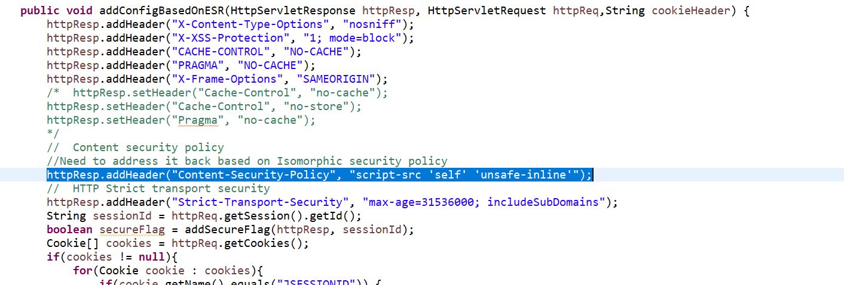

1. Getting Browser Errors

